**Jesus**

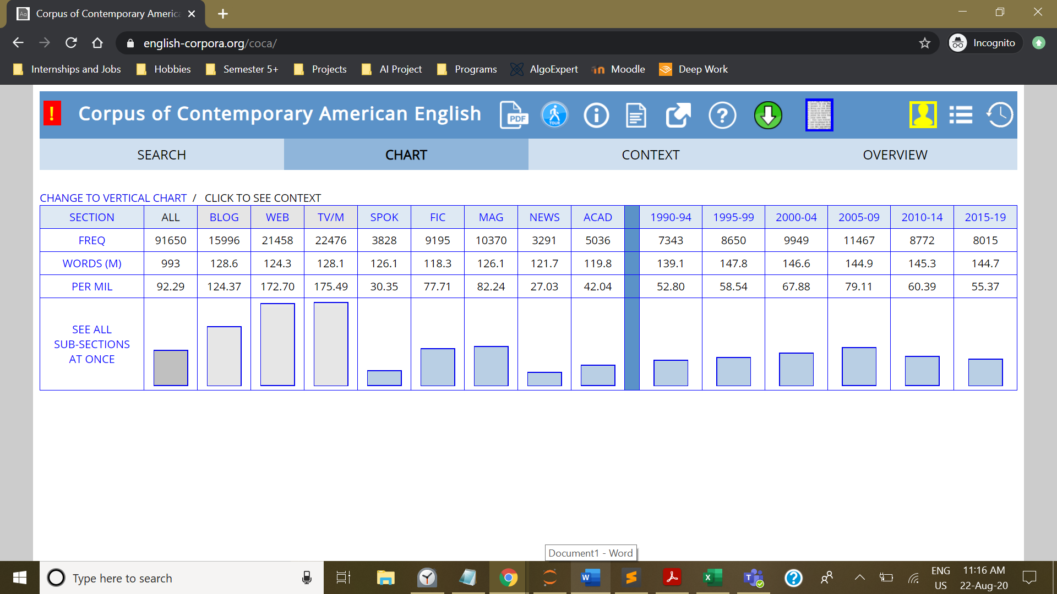

Inference: There seems to be more discussions in TV and the internet of Jesus than news or academic medium.

**Gandhi**

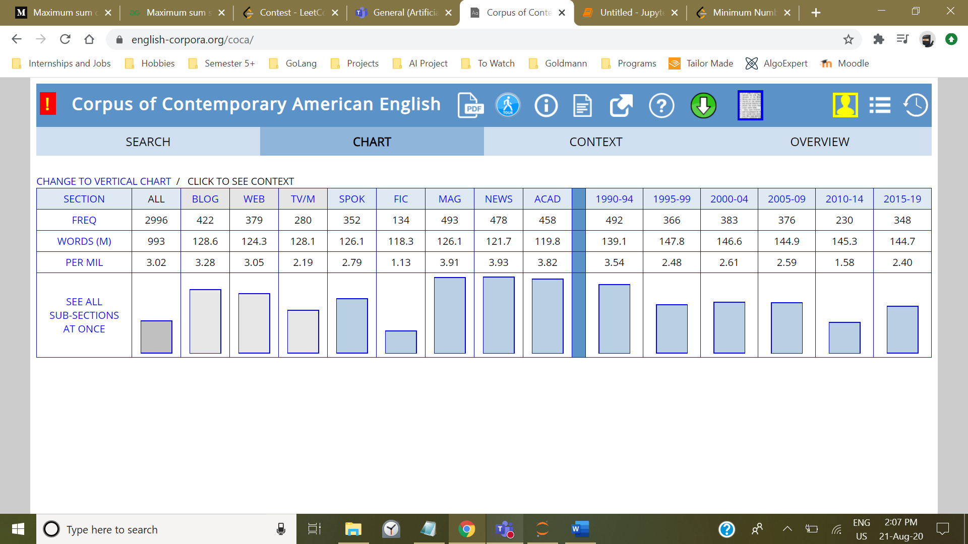

Inference: Gandhi seems to be not so popular in American literature. He seems to be mostly a subject of academic discussions.

**Narendra Modi**:

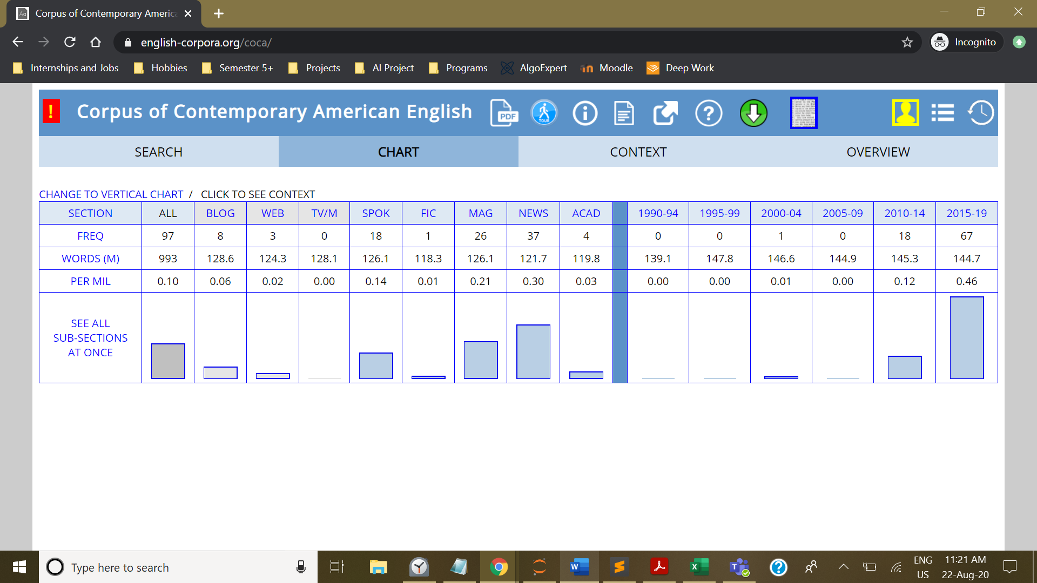

Inference: Prime Minister Narendra Modi seems to be virtually non-existent in American literature. But, we see a good spike at end of 2014 to 2019 when he was became Prime Minister.